Parth Babbar

Commercial banking operation

**Introduction:**

Commercial banks are financial entities that play an important role in the US economy. They fulfil critical roles by accepting deposits and granting loans, providing individuals, corporations, and governments with the capital they need to conduct economic activity.

**Core Operations:**

1. **Deposit Taking:**    
    **1. Saving Accounts:** Individuals and corporations can open accounts that earn interest. **2. Checking Account:** Offering non-interest-bearing accounts for daily transactions.
2. **Lending:**  
    **1.Consumer Loans:** These include personal, vehicle, and home loans.  
    **2.Commercial Loans:** Business loans, such as working capital, equipment finance, and commercial real estate loans.  
    **3.Credit Cards:** Offer revolving credit to consumers and corporations.
3. **Payment & Settlement Service:**  
    **1.Electronic monies Transfers (EFT):** Enables the electronic transfer of monies.  
    **2.Wire Transfers:** Allows for the speedy transfer of cash both locally and internationally.  
    **3.Payment Processing:** Handling debit and credit card payments.
4. **Wealth Management and Financial Advisory:**  
     
    **1.Investment Services:** We provide brokerage accounts and investment guidance.  
    **2.Financial Planning:** We offer retirement, estate, and tax planning services.
5. **Cash Management:**   
    1.Liquidity Management: Ensuring adequate liquidity for operating requirements.  
    2.Risk Management: Managing interest rate, foreign currency, and credit risks.

**Regulatory Environment:**

Commercial banks in the United States are regulated by many federal and state authorities to assure their stability, solvency, and compliance with laws and regulations. The key regulatory bodies include:

1. **Federal Reserve System (Fed)**
2. **Office of the Comptroller of the Currency (OCC)**
3. **The Federal Deposit Insurance Corporation (FDIC)**
4. **The Consumer Financial Protection Bureau (CFPB)**

**Key Players:**

1. **JPMorgan Chase & Co.**
2. **Bank of America**
3. **Wells Fargo & Co.**
4. **Citibank**
5. **U.S. Bancorp**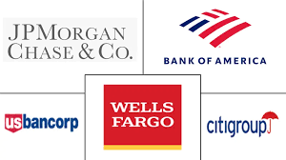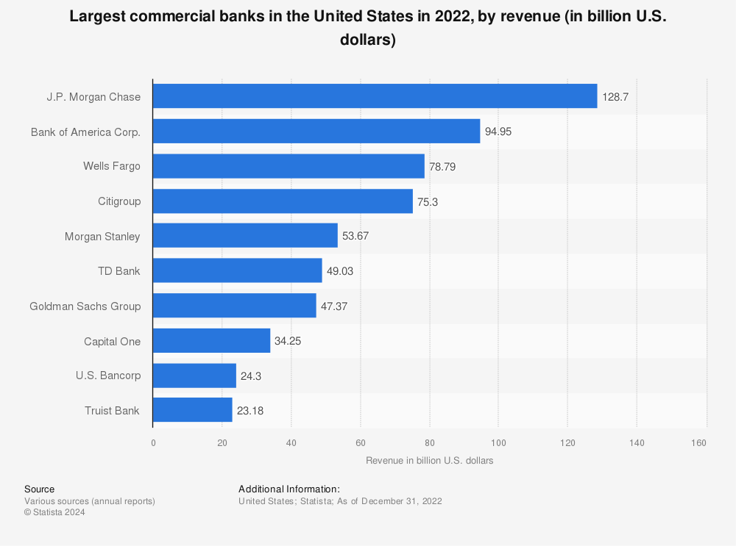

**Statistical Data:**

1. **Number of Banks:** As of 2023, there are around 4,470 commercial banks operating in the United States, down from over 14,000 in the mid-1980s due to mergers and acquisitions.  
     
   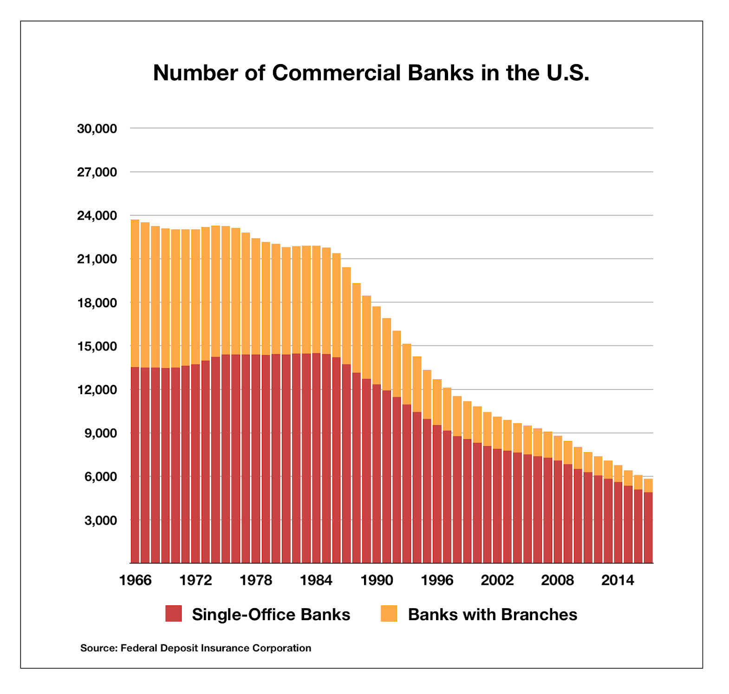
2. **Total Assets:** As of the end of 2023, commercial banks in the United States have around $23.7 trillion in total assets.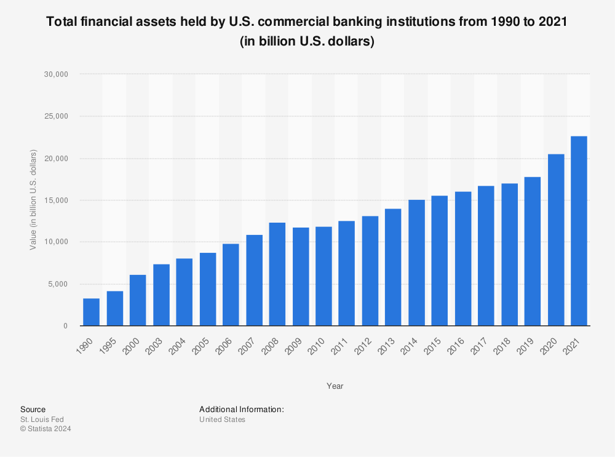
3. **Loan and Deposit Statistics:  
    1.Total Loans**: $10.3 trillion  
     **2.Total Deposits**: $17.3 trillion
4. **Employment:** Commercial banks employ over 2.5 million people throughout the United States.
5. **Profitability:  
    1.Return on Assets (ROA)**: Averaged around 1.36%.  
    **2.Return on Equity (ROE):** Averaged around 12.9%.

**Conclusion**:

Commercial banks play an important role in the United States' financial system, offering key services that help to enable economic activity. They operate inside a complex regulatory structure that is intended to promote stability and safeguard customers. Despite the obstacles posed by economic swings and technological improvements, commercial banks continue to adapt and evolve to fulfil the demands of their clients.